**Analysis of Wireless Communication Link using Matlab**

**LAB # 09**



**FALL 2021**

**CSE402L-Digital Signal Processing**

Submitted by: **Ashfaq Ahmad**

Registration No: **19PWCSE1795**

Class Section: **B**

“On my honor, as student of University of Engineering and Technology, I have neither given nor received unauthorized assistance on this academic work.”

Student Signature: ______________

Submitted to:

**Prof. Ihsan Ul Haq**

February 23, 2022

**Department of Computer Systems Engineering**

**University of Engineering and Technology, Peshawar**

**CSE 402L: Digital Signal Processing**

|  |  |  |  |  |
| --- | --- | --- | --- | --- |
| **Demonstration of Concepts** | **Poor (Does not meet expectation (1))**  The student failed to demonstrate a clear understanding of the assignment concepts | **Fair (Meet Expectation (2-3))**  The student demonstrated a clear understanding of some of the assignment concepts | **Good (Exceeds Expectation (4-5)**  The student demonstrated a clear understanding of the assignment concepts | **Score**  **30%** |
| **Accuracy** | The student completed ( <50%) tasks and provided MATLAB code and/or Simulink models with errors. Outputs shown are not correct in form of graphs (no labels) and/or tables along with incorrect analysis or remarks. | The student completed partial tasks (50% - <90%) with accurate MATLAB code and/or Simulink models. Correct outputs are shown in form of graphs (without labels) and/or tables along with correct analysis or remarks. | The student completed all required tasks (90%-100%) with accurate MATLAB code and/or Simulink models. Correct outputs are shown in form of labeled graphs and/or tables along with correct analysis or remarks. | **30%** |
| **Following Directions** | The student clearly failed to follow the verbal and written instructions to successfully complete the lab | The student failed to follow the some of the verbal and written instructions to successfully complete all requirements of the lab | The student followed the verbal and written instructions to successfully complete requirements of the lab | **20%** |
| **Time Utilization** | The student failed to complete even part of the lab in the allotted amount of time | The student failed to complete the entire lab in the allotted amount of time | The student completed the lab in its entirety in the allotted amount of time | **20%** |

**Objectives:**

1. To Know about QAM
2. To know about Noisy channel
3. To know about Bit error rate
4. To know about Pulse-shaping filters
5. To know about Multipath channel
6. To know about Ideal OFDM
7. To know Practical OFDM
8. Introduction

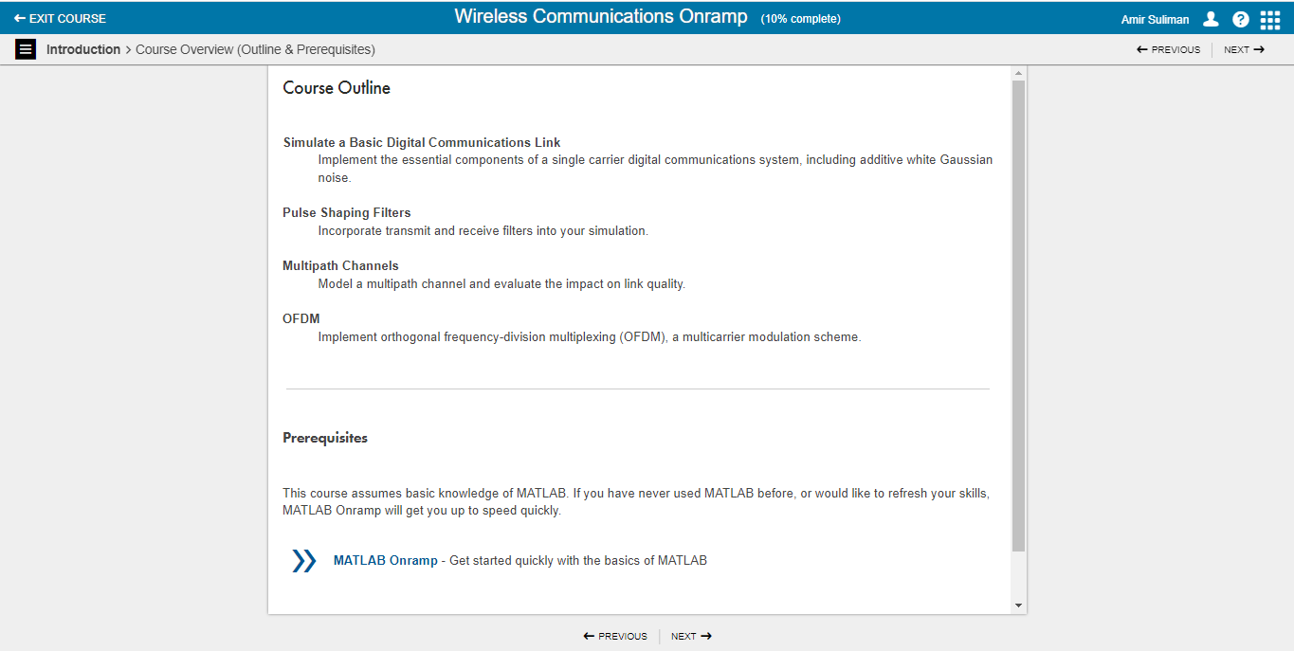

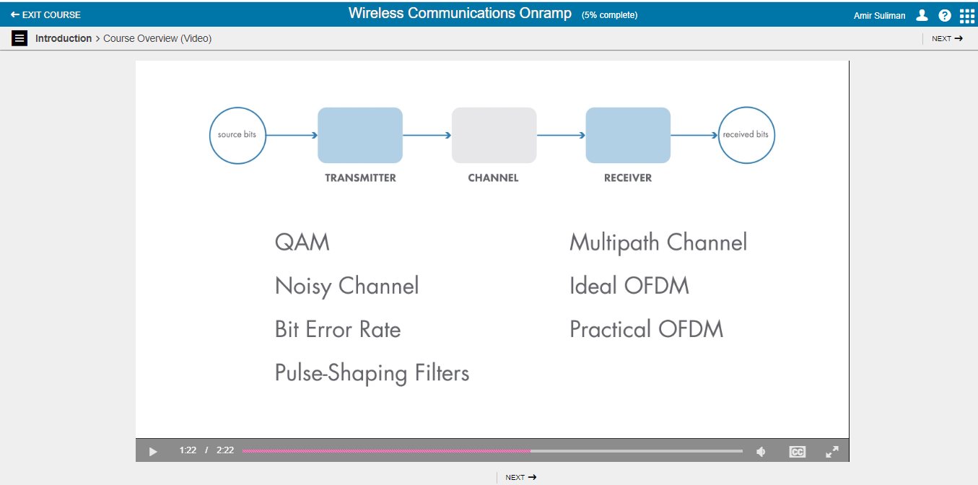

1. Simulate a Basic Digital Communications Link

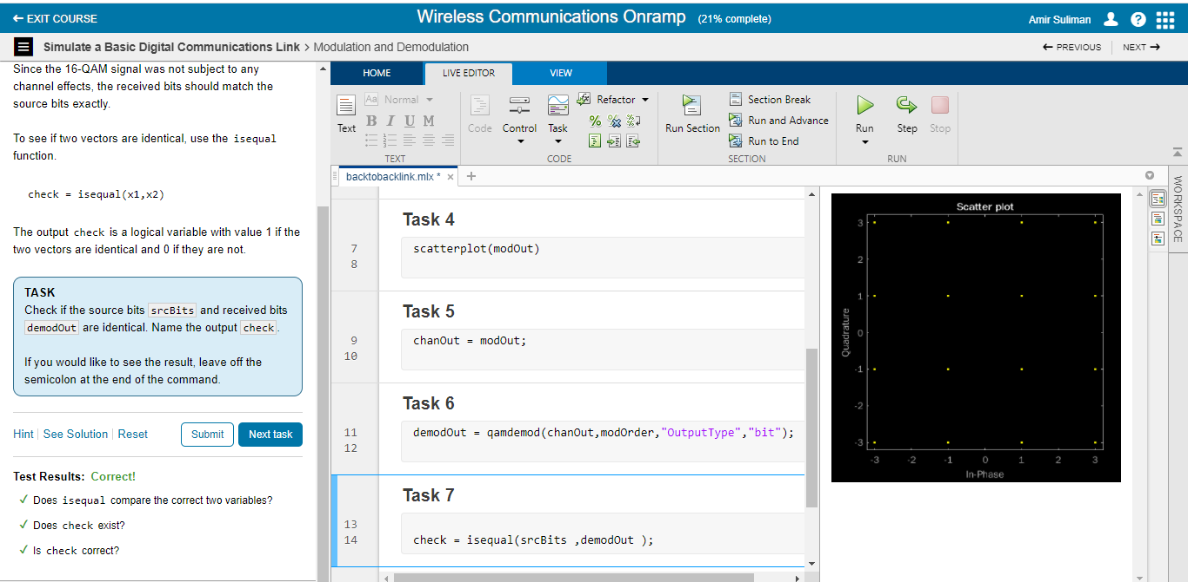

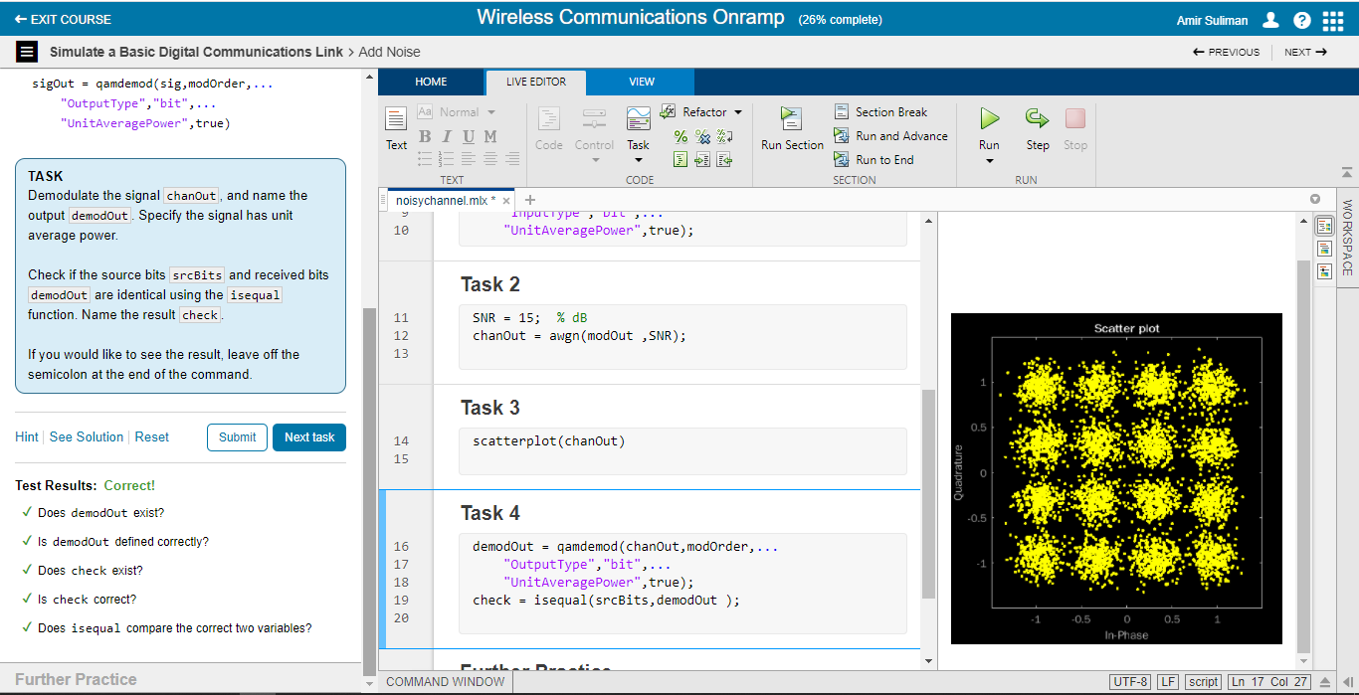

1. Pulse-Shaping Filters

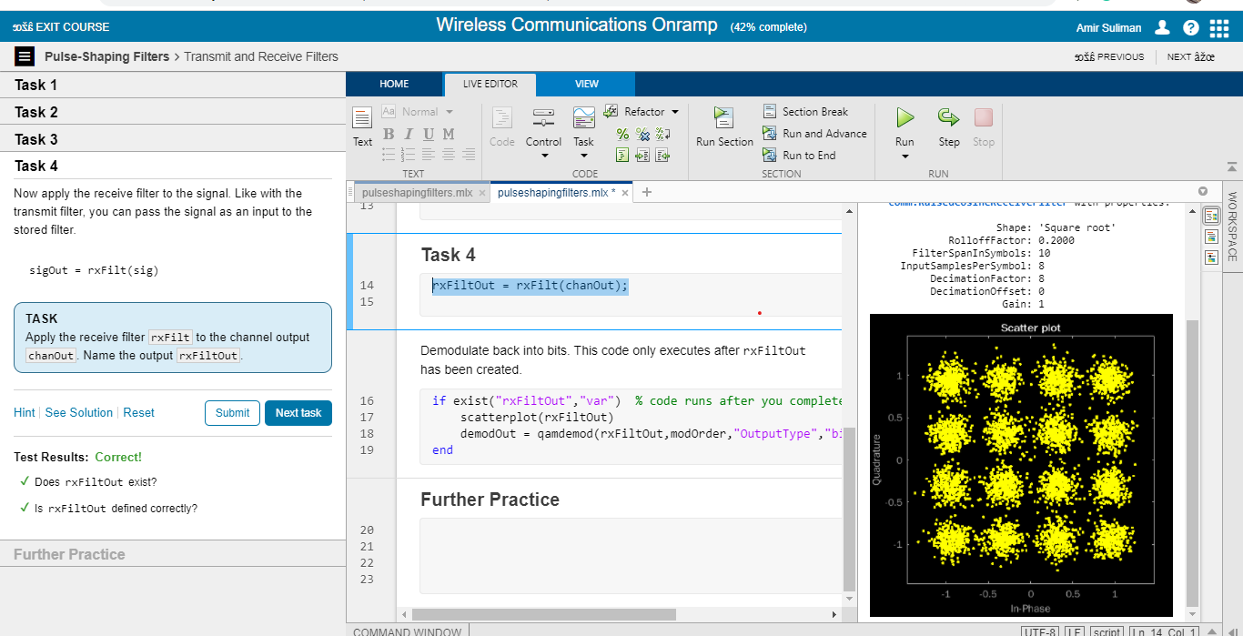

1. Multipath Channels

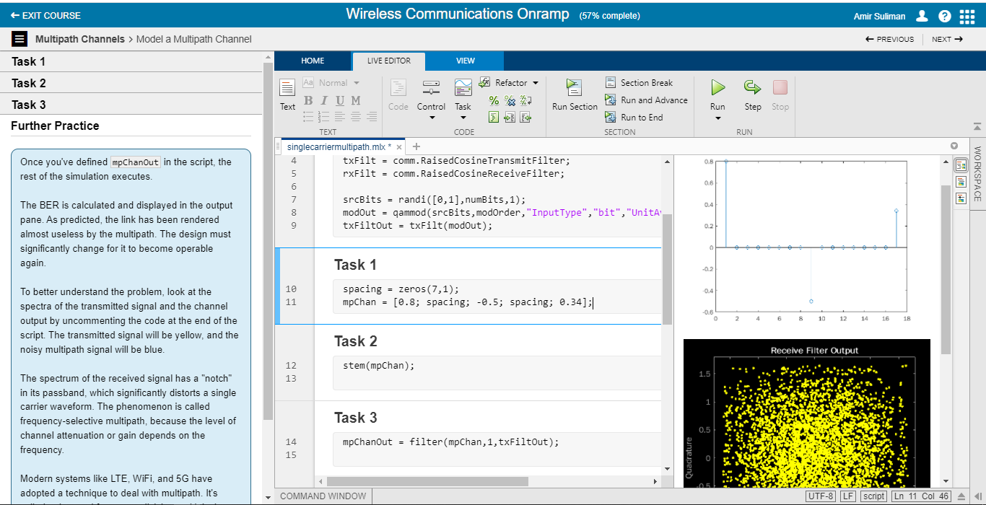

1. OFDM

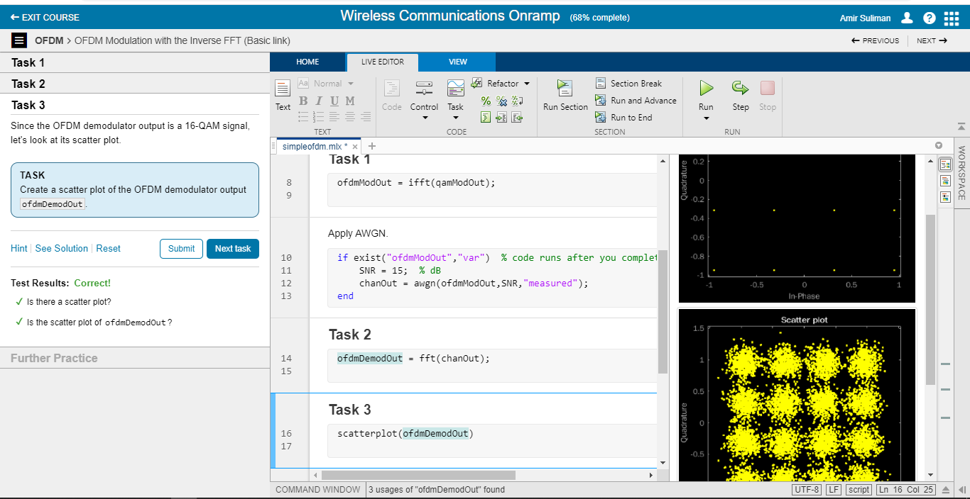

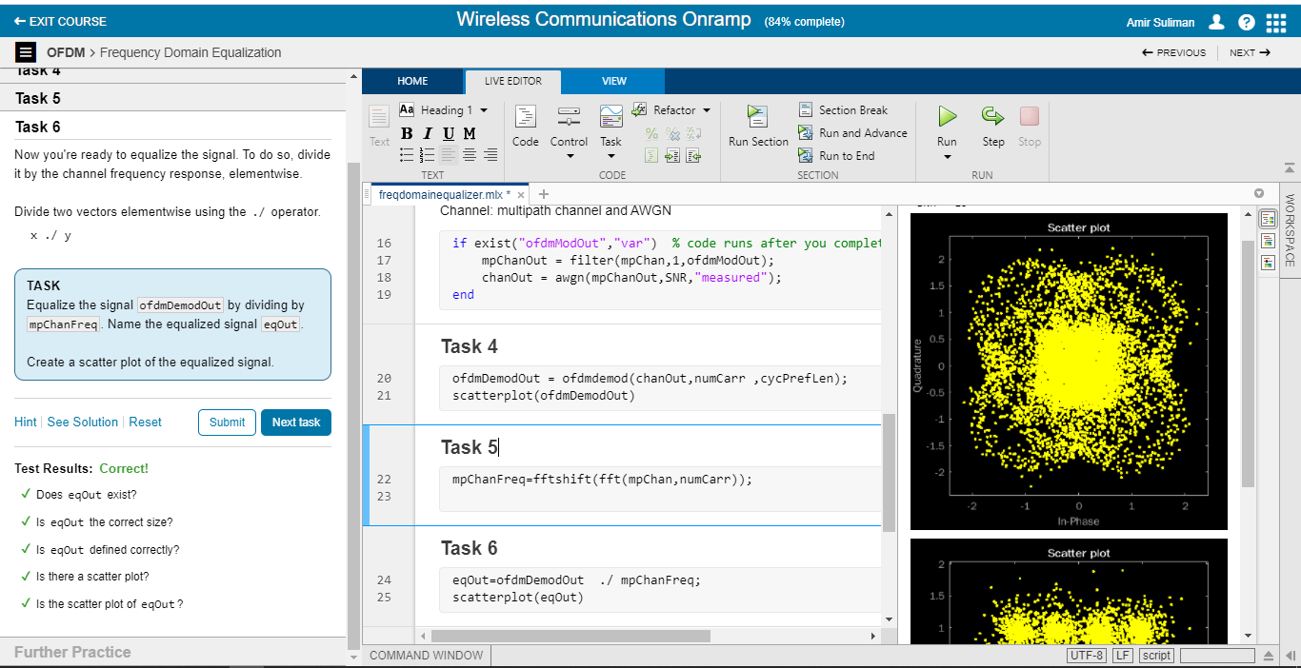

1. Conclusion

